**Education for Sustainability: Perception of Teachers and Practices in Urban Primary Schools of Mysore**

Gangotri Dash, Research Scholar and Dr. Mohan A.K., Assistant Professor,

Department of Studies in Social Work, University of Mysore, Mysuru

Abstract:

*Sustainable development requires a change in the way people think and act. Decade of Education for sustainable development (DESD)’s goal is to “integrate the principles, values, and practices of sustainable development into all aspects of education and learning”1. To impart quality education various methods such as smart class, English mentor, 3D lab, mindspark, etc. are facilitated. Teachers are also using different strategies like project based learning, brain storming, group learning etc. However, a well-designed project can fail when students respond in thoughtless and maladaptive ways2. Even though many educational methods are available, sustaining sustainability in the classroom and school campus is still a challenge. Stakeholders such as school administration, teachers, students, parents and community have key roles to initiate and maintain sustainability. Study has included teachers working in private primary schools as respondents to explore and understand their perception and opinion on various educational strategies and methods. Teachers were interviewed using a structured interview schedule. It has covered various approaches of education imparted by teachers and views of teachers on promotion of students’ talents and skills and execution of project based learning.*

1. UNESCO.(2005).UN Decade of Education for Sustainable Development: 2005-2014. [www.unesco.org/education/desd](http://www.unesco.org/education/desd)
2. Meyer, D.K., Turner, J.C., & Spencer, C.A. (1997). Challenge in a mathematics classroom: Students’ motivation and strategies in project-based learning. Vol.97, No.5, pp. 501-521

**Background**

Although science and technology and financial bodies are providing basis for development but sustainable development requires a change in the way people think and act. To bring this change time demands systematically integrating education for sustainable development in all levels from early childhood to higher education, workplace learning and even in technical and vocational education and training. Education for sustainable development can help everyone to acquire the values, skills and knowledge needed to build a sustainable future (UNESCO, 2012). Decade of Education for sustainable development (DESD)’s goal is to “integrate the principles, values, and practices of sustainable development into all aspects of education and learning” (UNESCO, 2005). UK’s ‘Learning and Skills Council’ (LSC, 2005) considers sustainable development as the heart of all learning. Stressing on importance of education for sustainable development, LSC mentions the need for all learner to acquire skills that will make them able to lead their lives and work in a sustainable way. Education for sustainable development includes a range of environment and social skills. A report by UNESCO (2005b) discussed the skills need of young people which included cognitive, reflective, self-management and social skills. These skills are necessary in all four pillars of education; learning to know, learning to do, learning to live together and with others and learning to be.

Our aspiration to build sustainable environment can’t be attained without having a proper understandable structure which will help different stakeholders to understand the facts and to act accordingly. Otherwise complexity of issues and differences of opinion to act sustainably will create confusion among the people (Brandon & Lombardi, 2005). An envisioning process with fifteen higher education institutions of OECD (Organization for Economic Co-operation Development) member countries emphasized adapting initiatives to the unique situation of each institutions (Johnston, 2007).

Blatchford et al. (2010) emphasized on education for sustainable development for young children by highlighting importance of early education. According to Goteborg recommendations, early education is the starting point of lifelong learning, understanding gender, embracing complexities of transformative learning, enhancing indigenous knowledge, sustainable living practices, basic human rights and learning through experience. Most of the illustrations and cases discussed by Blatchford et al. (2010) stressed on involving young children in activities (design of playground, water conservation, composting, using resources etc.) which will provide real life experience, make them understand sustainable resource utilization, and enhance their understanding about the natural and social environment. For enhancing sustainability skills among young children, projectsbased learning should support children in making their own informed decisions, asses their understanding, knowledge and interest at the starting point, involve community and families and build capacity of the practitioners.

Various institutions, government and private, are striving towards building capacity of student. A report by department of school education and literacy, government of India discussed about various facilities available in private schools which include smart class, English mentor, 3D lab, smart class tabs, Mindspark etc. to make learning effective. Many educational and learning strategies such as group learning, project and problem based learning, brainstorming etc. are being used by educators to make education interesting and practical. The problem based learning helps students to identify facts, generate hypothesis and apply new knowledge by evaluating the issue at each step. This also develops problem solving skills and life-long learning skills. A good problem is not sufficient condition for effective problem based learning. Facilitator plays a vital role in modelling thinking skills and supporting students to carry out various stages of problem solving (Hmelo-silver, 2004). However as per Meyer (1997) a well-designed project can fail when students respond in thoughtless and maladaptive ways. Barron, et.al (1998) emphasize that doing with understanding is important rather than doing for the sake of doing. A project can effectively provide learning experience if it can create opportunities for students to understand what they are doing and how it will be helpful to themselves and others. Although many educational innovations have already been in use but Johnston (2007) highlights that Initiating and maintaining sustainability (environment, economy and quality of life) in the classroom, on the campus and in the community remains a major challenge on a global scale.

This study strives to understand various educational practices in private schools and effectiveness of those strategies. There are several researches which have discussed learning practices of schools but this study has emphasized the sustainability of those practices.

**Research objectives:**

1. To find out the learning activities adopted by teachers to enhance sustainability skills of students
2. To understand the approaches for talent promotion in schools

**Methodology**:

A qualitative study was conducted to explore and understand educational practices from sustainability point of view. Around 80 private schools are there in Mysore city which provides primary education to students. Out of which 10% schools (eight) schools were chosen randomly for the study. Prior to data collection, permission was taken from the district education authority and consents were taken from the teacher respondents. Data collection was done in March 2016. For data collection interview schedule having both open and close ended items was used. For demographic details, close ended items were used and open ended items covered the main objectives. To get the views of teachers about their educational practices and to understand the sustainability of such activities, few open ended questions were discussed such as ‘what activities do you conduct in the classroom to enhance knowledge, and skills of students?’, ‘What all activities do you conduct to provide practical experience to students?’, ‘Do you encourage them to collect information by themselves and learn by doing?, ‘how do you do that?’, ‘where do students do such activities (at classroom or at home/ individually or in group)?’, ‘Do you asses the effect of such activities on child’s learning?’ and ‘what are the usefulness of such activities?’, ‘what do you do with the models, charts etc. submitted by students?’ etc. To understand the approaches to promote talent in school, teachers were asked about various activities (apart from academic) they organized at classroom and in school. A very specific question ‘whom do you generally ask to participate when there is any competition?’ was asked to teachers to know how fairly children were given chance at schools to exhibit their talent and to build their capacities.

**Demographic details:**

Out of eight schools, four schools (50%) are following Karnataka state syllabus and other four schools (50%) are following CBSE syllabus. However except one school, rest seven schools’ medium of education is English. In five schools, number of students is less than hundred i.e. 42, 60, 73, 85, and 90 and in three schools, students’ strength is more than hundred i.e. 136, 257 and 690. Out of total forty one (41) primary level teachers, nineteen teachers (46.3%) said that they used to engage five to six class per day, five teachers (belong to same school) said that they were handlingsix to seven classes per day and rest seventeen teachers (41.46%) revealed that they were assigned seven to eight class per day.

Table no. 1: Distribution of respondents (teachers) on the basis of subject taught by them

|  |  |  |
| --- | --- | --- |
| Subject | Number of teachers teach the respective subject | Percentage N= 41 |
| English | 19 | 46.34 |
| Kannada | 17 | 41.46 |
| Hindi | 9 | 21.95 |
| Mathematics | 19 | 46.34 |
| Science | 14 | 34.15 |
| Social Science | 19 | 46.34 |
| General knowledge | 1 | 2.44 |
| Physical Education | 2 | 4.88 |
| Computer | 1 | 2.44 |

It was observed that teachers were handling multiple subjects in primary level. Randomly five teachers from each school participated in the study. Table no. 1 shows the details of various subjects taken by teachers.

**Discussion:**

Activities facilitated by teachers:

Innovations and new ideas are continuously evolving in the field of education. For the promotion of sustainability skills among students, experiential learning is encouraged. When asked about the types of learning activities followed by teachers to enhance learning skills of students; writing and reading activities were mostly shared by the teachers. Apart from these routine academic activities, teachers also talked about storytelling, games, and puzzles. However these activities were subject and class specific. Storytelling and games were often done for lower classes in primary division (1st and 2nd standard) and rarely for the higher classes (standard 3rd, 4th and 5th). Out of forty one respondents, majority forty teachers (99%) shared that they used to ask students (Class I to V) to collect pictures, charts and other materials and to make projects, models based on the lesson in syllabus.

Table No. 2: Details of facilitation of projects at schools

|  |  |
| --- | --- |
| Where do students do projects | Number of students |
| Both classroom and home | 31.7% (13) |
| Home | 65.8% (27) |
| Not answered | 2.5% (1) |
| Total | 41 |

Chart No. 1

Further discussion about place where students do their projects or models revealed that one third of the teachers used to ask students to collect information and to make projects at home as well as in the classroom, but two third of the teachers used to give such activities only as home work(table No. 2). Again only eight teachers (19.5%) facilitated both individual and groups activities to do models and projects in the class room (Chart no. 1). Both individual and group work has its own impact on child’s learning. However it was observed while interviewing that group activities were not encouraged much by the teachers.

Effects of the activities:

Collecting pictures, taking printouts, and making models etc. for learning purpose consume time, resources and energy. Hence it is essential to understand the effectiveness of these activities.In this study, except two teachers, who were confused about the usefulness of such activities, rest thirty-nine teachers talked in support of such activities. According to them these activities are useful for students (chart 2).

*‘Students enjoy to collect colorful images.’*

*‘Students love to exhibit their models.’*

*‘They find it more interesting than regular classroom sessions.’*

* *Extractions from discussion with teachers about learning activities* (Specifically collecting materials, images from internet sources, buying images for book stalls and fixing, making models at home)

Table. 3: Assessment of usefulness of activities

|  |  |
| --- | --- |
| Have you assessed usefulness of activities? | Percentage (count) |
| Yes | 60.9% (25) |
| No | 39.1% (16) |
| Total | 100% (41) |

Although majority of the respondent felt that making students to collect information, pictures, and making models etc. were beneficial but sixteen teachers (more than one third of the respondents) have never assessed the effect of such activities on students in terms of knowledge, or skills. The teachers who said that they have assessed the effect of these activities on development of skills in child, could not able to share any specific method or tool for assessment.

*­*

*‘I observed changes in children’s understanding’*

*‘Students used to explain the lesson in a better way’*

*‘It provides practical experience to students’*

* *Extractions from discussion with teachers about usefulness of learning activities* (Specifically collecting materials, images from internet sources, buying images for book stalls and affixing in note books, making models at home)

Sustainability of projects and models done by primary students:

Table No. 4: Views of teachers on children’s involvement in activities askedto do at home

|  |  |
| --- | --- |
| Views of teachers on involvement of children in activities when asked to do at home | (Count) Percentage |
| Children do by themselves | 2.1% (5) |
| Younger Children do with the help of parents | 34.1% (14) |
| Some may be depending completely on parents depending on project topic | 41.4% (17) |
| Don’t know | 9.7% (4) |

As most of the teachers ask students to collect picture and materials from outside and to make models at home, here, the major concerns are ‘who helps them to do so?’ and ‘If they take help from outside or from parents then up to what extent students get involved in the activities?’. Only five teachers (12.1%) felt that children might be doing these activities themselves. One third of teachers (14 teachers) said that younger children might be taking help from their parents. According seventeen teachers (41.4%), some students may be doing activities themselves and others may be taking help of elders at home, based on the interest and capacity of students and nature of project topic. The impact of such activities on the child’s learning and skills development is questionable, if there is more involvement of parents or other elder members of the family in doing the activity. Such activities may not be successful in terms of sustainable skill enhancement by providing practical learning experience. No teachers shared about the improvement of students’ analytical skills, thinking capacity, resource utilization ability, and awareness of sustainable use of learning material through such activities.

Sustainability of any educational activities do not only include how students do activities and what do they learn from the activities, it also include their ability to manage resources and use ideas or materials for future use. In this context, teachers were asked about maintenance of models or projects submitted by students. Almost all the teachers said that they used to return the models to students and they have not guided students about the preservation of their projects. None of the teacher know what students do with the models when they return to them.

*‘I return to students if model is not good otherwise I keep till the year end in the classroom and then return.’*

*‘We keep few good ones in the office and return rest to the students.’*

* Extraction from the discussion with teachers about maintenance of models submitted by students as a part of their learning activities.

Feeling accepted is very essential for sustainable growth. However, such opinion indicates bias attitude which violate accepting children as they are.

Talent promotion strategies by teachers:

Every child deserve equal opportunity to exhibit his/her hidden talent. School is the place where children get such motivation which strengthen their social and emotional skills. Apart from regular curriculum, schools have provision for many extracurricular activities which includes dance, drama, art, sports, music, craft, etc. All the eight schools have platform for such activities but when it comes to promote students to exhibit their talents, mostly teachers encourage the students who are good in specific performance and trained.

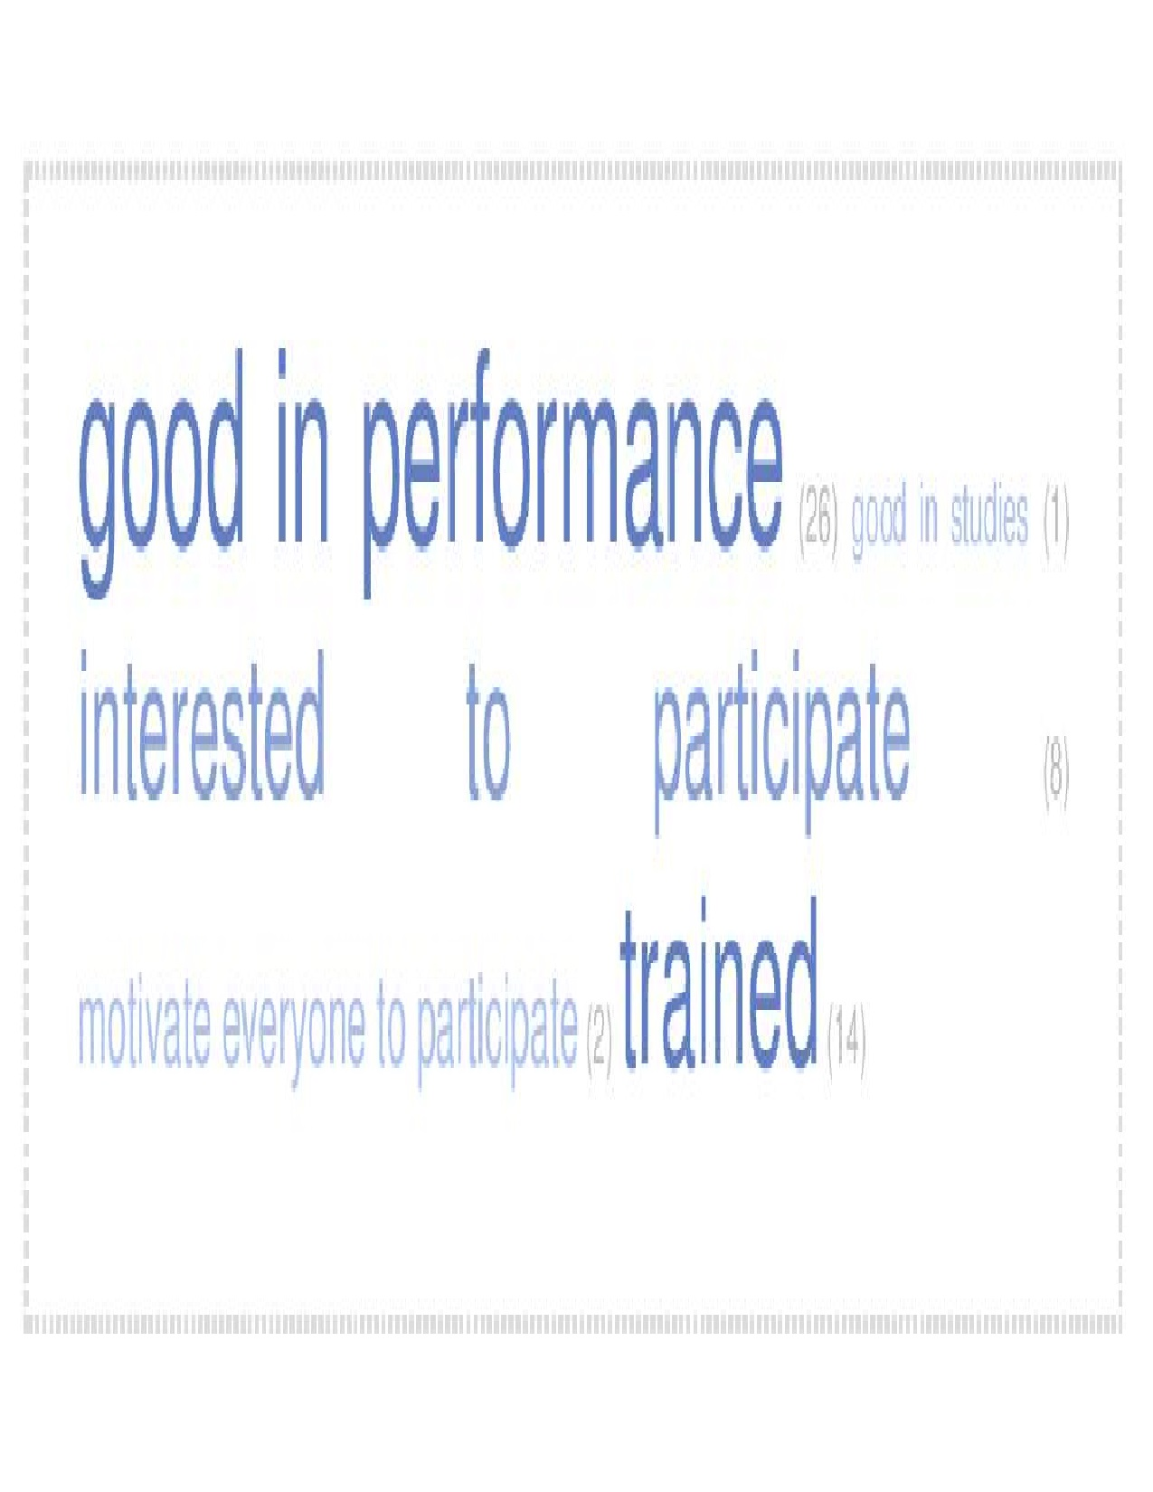**Word cloud: Teachers’ response to ‘whom do you ask to participate when there is any competition?’**

The discussions with the teachers about their strategies to make students participate in various extracurricular activities is presented in the form of a word cloud. Word cloud highlights the repetitive views of teachers. Only two teachers said that they used to motivate all the students to participate. However most of the respondent showed their preference for students who perform better (26) and students who are trained (14).

**Conclusion:**

Education can help for a sustainable future if all the stake holders, students, teachers, parents, community and government will have proper understanding of purpose of ‘education for sustainability’ and also the capacity to convert the concept into action. During the interview, teachers were asked about their role in ‘education for sustainability?’. All of them said that they have not heard of this concept. However, there were few (only three) who showed interest to know more about it. It is not that teacher are not involving sustainability elements in their teaching practices but proper understanding will encourage them for innovations, will make them able to understand the usefulness and outcome of various practices. Clarification about usefulness of activities is necessary to facilitate the activities systematically for the promotion of sustainability skills of students. Activities which include collection of information, pictures (from internet or other sources) and making of models or projects on different topics should provide practical experience and develop sustainability skills in terms of resource utilization, critical thinking, analyzing ability etc. Again when children create something, they should be guided properly to preserve their creation or to utilize it in a sustainable manner such as keeping it for future use, giving it for community service, donating to someone who needs etc. It is essential to encourage students to participate in different activities in early age in order to make them realise their strength, accept differences and help them to understand their interest for a sustainable future.

*References*

Barron, B.J.S., Schwartz, D.L., Vye, N.J., Moore, A., Petrosino, A., Zecn, L. &Bransford, J.D. (1998). Doing with understanding: Lessons from research on problem and project based learning. Vol. 7, 3-4, pp. 271-311

Blatchford, J.S., Smith, K.C., Samuelsson, I.P. (2010). Education for sustainable development in the early years. World Organization for early childhood education. [www.327matters.org/Docs/ESD%20book%20master.pdf](http://www.327matters.org/Docs/ESD%20book%20master.pdf)

Brandon, P.S & Lombardi, P.(2005). Evaluating Sustainable Development in the built environment. Blackwell publishing company

Department of education and Literacy, Government of India. (n.d) Implementations in Private School-India. <http://mhrd.gov.in/sites/upload_files/mhrd/files/upload_document/Annexure%20V.pdf>.

Education for Sustainable Development and Technical & Vocational Education & Training: Promoting Skills for Sustainable Development. (2012) United Nations Education, Scientific and Cultural Organisation.www.unesco.org/education

Hmelo-Silver, C.E. (2004). Problem based learning: What and how do students learn? Educational Psychology review. Vol. 16, no. 3, pp. 235-266

Implementations in Private School- India. Department of School Education and Literacy. Ministry of human resource development. Government of India.

Johnston, A. (2007). Higher education for sustainable development.[www.oecd.org/...**education**/centreforeffective**learning**environmentscele/4](http://www.oecd.org/...education/centreforeffectivelearningenvironmentscele/4).

Learning and Skills Council. (2005). From here to sustainability: The learning and skills Council’s strategy for sustainable development. Conventry, [www.lsc.gov.uk](http://www.lsc.gov.uk)

Meyer, D.K., Turner, J.C., & Spencer, C.A. (1997). Challenge in a mathematics classroom: Students’ motivation and strategies in project-based learning. Vol.97, No.5, pp. 501-521

UNESCO.(2005).UN Decade of Education for Sustainable Development: 2005-2014. [www.unesco.org/education/desd](http://www.unesco.org/education/desd)

UNESCO (2015b). Contribution to more sustainable future: Quality education, life skills, and education for sustainable develop. ent. Division for promotion of quality education, France