3.0. Introduction

The subject Information Retrieval, though not a part of Internet, but has been changed considerably with the expansion of the World Wide Web and advent of new graphical user interfaces and mass storage devices. Still in Web the search engines continue to use indexes, which are very similar to those used by librarian a century ago. The additional features of the search engines like – low cost, greater access, and publishing freedom, have allowed people to use web as a highly interactive medium. Despite all advance features, people still find it difficult to retrieve information relevant to their information need. Secondly, the quick response from Web is becoming more and more a pressing factor. To cope with the information explosion, 85% of all Web users use various search engines and search tools to find relevant Web sites for specific information (Kobayashi & Takeda, 2000).

The ultimate goal of search engines is to recall information that is both accurate and relevant. Existing search engines on the Web have incorporated a number of techniques to assist in both the recall and accuracy (precision) of information. A common phenomenon of modern search engines is an inverse relationship between precision and recall. That is, while a lot of irrelevant information may be retrieved only a small amount of relevant information tends to be retrieved (Greg, 2004). A web searcher can try to improve the rate of retrieval of relevant materials with the selection of appropriate search tools (search engines), search techniques, and query formulation.

Natural Language Processing in query formulation - To avoid forcing searchers to memorize Boolean or other query languages, some systems allow them to type in a question, and use that as the query: this is known as "Natural Language Processing" (NLP). The simplest processing just removes stop words and uses a vector search or other statistical approach. Some sophisticated systems try to extract concepts using linguistic analysis, and match those against concepts extracted by the indexer (Searchtools, 2010). For any modern search engine the NLP has been an inseparable entity.
3.1.1. Genesis of Information Retrieval

Information Retrieval (IR) deals with representation, storage, organization of, and access to information items. The representation and organization of the information items should provide the user with easy access to the information in which he is interested (Baeze-Yates, & Riberio-Neto, 1999). Information Retrieval begins with collection of data and represents them digitally to make accessible to the users. The retrieved documents aim at satisfying a user’s information need usually expressed in natural language. The efficient retrieval of related information is a major search goal of Library and Information Science. IR has always been the focus of information scientists and reference librarians, trying to provide relevant materials in response to a user's query.
Information Retrieval is concerned with finding appropriate information from vast bodies of accumulated information and its related data. IR is a term that came into use in the early 1950s in the United States when the first computer generation appeared, and has become widely known since the 1960s. The concept of IR has become used in the computing area instead of the concept of ‘Documentation’ that was widely used by librarians in the 1940s. Documentation included processes, such as, collecting, categorizing and applying, in order to gather correct information from among the variety of available information. In the 1980s, awareness of IR became more prevalent world wide because of the spread of the Personal Computers (PC) and development of communication networks. In 1990s information were searched on Internet through search engines. The table depicts the actual history (Cho, & Richards, 2007):

Table – 3.1. History of Information Retrieval

1950s Manually searching, indexing and categorizing books in the library
1960s Computer based search – Offline Batch method, Databank (Dialog, Orbit, Medlars) appear.
1970s Building and use of Online Systems.
1980s Online Database and Online Databank growth, CD-ROM Database appear.
1990s Searching information via the Internet.

In the context of information retrieval (IR), information, in the technical meaning given in Shannon's theory of communication, is not readily measured (Shannon, & Weaver, 1964). 'Information retrieval is the term conventionally, though somewhat inaccurately, applied to the type of activity discussed in this volume. An information retrieval system does not inform (i.e. change the knowledge of) the user on the subject of his inquiry. It merely informs on the existence (or non-existence) and whereabouts of documents relating to his request' (Lancaster, 1968). In addition the frequency of occurrence of these words in the body of the text could also be used to indicate a degree of significance. This provided a simple weighting scheme for the 'keywords' in each list and made available a document representative in the form of a 'weighted keyword description' (Luhn, 1957). Users of Web search engines generally require the requested information to be immediately available, accurate and suit (Lawrence, 2000).

According to Rijsbergen (1979) in his book titled “Information Retrieval”, there are three (3) main areas of research in IR, which between them make up a considerable portion of the subject. They are: content analysis, information structures, and evaluation. Briefly, the first is concerned with describing the contents of documents in a form suitable for computer processing; the second with exploiting relationships between documents to improve the efficiency and effectiveness of retrieval strategies; the third with the measurement of the effectiveness of retrieval. Since the emphasis in this research is on evaluation, the following section will discuss the said area in great detail.

Wikipeadia (2010) describes Information Retrieval system as: Information Retrieval (IR) is the art and science of searching for information in documents, searching for documents themselves, searching for metadata which describe documents, or searching within databases, whether relational stand-alone databases or hypertext networked databases such as the Internet or intranets, for text, sound, images or data. There is a common confusion, however, between data retrieval, document retrieval, information retrieval, and text retrieval, and each of these have their own bodies of literature, theory, practice and technologies. The term "information retrieval" was coined by Calvin Mooers in 1948-50. Web search engines such as Google and Lycos are amongst the most visible applications of information retrieval research.

3.1.2. Information Vs. Data Retrieval

Data retrieval in the context of an Information Retrieval System, consists mainly of determining which documents of a collection contain the keywords in the user query which, most frequently, is not enough to satisfy the user information need. In fact, the user of an IR system is concerned with retrieving information about a subject than with retrieving data, which satisfies a given query. Thus, for a data retrieval system, a single erroneous object among a thousand retrieved objects means a total failure. For an information retrieval system, however, the retrieved objects might be in accurate and small errors are likely to go unnoticed. The main reason for this difference is that information retrieval usually deals with natural language text that is not always well structured and could be semantically ambiguous. On the other hand, a data retrieval system (relational databases) deals with data that has a well-defined structure and semantics (Baeze-Yates, & Riberio-Neto, 1999).

3.1.3. Information Retrieval Performance

According to (Leighton and Srivastava, 1999), Information Retrieval Performance refers to an evaluation of an IR system in terms of the quality of the answers it generates with regard to a set of test queries. The quality of the answer set is evaluated by comparing the documents in it with those in a set of documents (provided by specialists) known to be relevant to the test query in focus. Evaluation is one of the three basic areas of research in IR. Evaluation of IR is mainly concerned with the measurement of effectiveness of retrieval. Much of the research and development in information retrieval is aimed at improving the effectiveness and efficiency of retrieval. Thus, much effort and research has gone into solving the problem of evaluation of information retrieval systems.

3.1.4. Information Retrieval Evaluation Methodology

So far, there is no definite methodology for IR evaluation being published but the researcher decided to compile the most significant evaluation criteria methods and finally came out with the term “Information Retrieval Evaluation Methodology”. The criteria measures include recall and precision. After Cranfield II project (Cleverdon et al., 1966) Cleverdon, (1972) was of the view that 'Within a single system, assuming that a sequence of sub-searches for a particular question is made in the logical order of expected decreasing precision, and the requirements are those stated in the question, there is an inverse relationship between recall and precision, if the results of a number of different searches are averaged.' Lesk and Salton (1969) subsequently showed that a dichotomous scale on which a document is either relevant or non-relevant, when subjected to a certain probability of error, did not invalidate the results obtained for evaluation in terms of precision (the proportion of retrieved documents which are relevant) and recall (the proportion of relevant documents retrieved).

Recall and Pression
Consistent to Rijsbergen’s statement, Zhang Wang (2001) also said that a very good quality search engine is said to have high precision and recall. His definition of precision is a measure of the usefulness of a hitlist while recall is a measure of the completeness of the hit list. Recall is a measure of how well the engine performs in finding relevant documents. Recall is hundred percent (100%) when every relevant document is retrieved. In theory, it is easy to achieve good recall: simply return every document in the collection for every query. Therefore, recall by itself is not a good measure of the quality of a search engine.

Recall = No of relevant hits in hit list / No of relevant documents in the collection.

In most search engine evaluation studies, recall measurement is omitted because it is impossible to assume how many relevant items there are for a particular query in the huge and ever changing Web system.

Precision = No of relevant hits in hit-list / No of hits in hit-list

Precision is a measure of how well the engine performs in not returning non-relevant documents. Precision is hundred percent (100%) when every document returned to the user is relevant to the query. There is no easy way to achieve hundred percent (100%) precision other than in the trivial case where no document is ever returned for any query. The relationship between precision and recall could be described in Figure 2-II.

Figure – 3.1 : Relationship between Precision and Recall

Source: (Wang, 2001)

Again it is repeated here that precision is the ratio of the number of relevant documents retrieved to the total number of documents retrieved, and recall is the ratio of the number of relevant documents retrieved to the total number of relevant documents (both retrieved and not retrieved).

3.1.5. World Wide Web and Information Retrieval

World Wide Web (WWW also know as W3) the “wide-area hypermedia information retrieval initiative” (World Wide Web Consortium, 2010), is the collection of globally distributed text and multimedia documents and files and other network services linked in such a way as to create an immense electronic library from which information can be retrieved quickly by intuitive searches. "The Web was developed to be a pool of human knowledge, which would allow collaborators in remote sites to share their ideas and all aspects of a common project." (Wardrip-Fruin & Nick, 2003). The Web represents the application of hypertext technology and a graphical interface to the Internet to retrieve information that is contained in specially formatted documents that may reside in the same computer or be distributed across many computers around the world.

The three main elements of Web are (i) the Hypertext Markup Language (HTML), to write contents, (ii) the HyperText Transfer Protocol (HTTP) defines a set of standards for transmitting Web pages across the Internet, (iii) the Universal Resource Locator (URL) is a standardized naming convention for identifying a Web document or file, in a sense the address of a link. The combined output is called the Web because it is made up of many sites, all linked together, allowing users to travel from one site to the next by clicking on a hyperlink.

Web sites, or Web pages, are really Internet sites that all use the same techniques and HTML tags to create multimedia documents with hypertext links. Each Web page can contain many screens or printed pages of text, graphics, audio, and even video, and the starting point for any Web site is called its home page. Although each page is an Internet site, it must be accessed via a special program called a Web browser, which can translate the HTML into the graphical images, text, and hypertext links intended by the creator of the page.

3.1.5.1. Web Searching Overview
Web is the biggest deposit of information interlinking the digital hypertext documents all across the Internet. The process of retrieval of information from web is a complex matter but everybody’s affaire.
3.1.5.1.1. A Brief History of Web Searching
For web searching, the search engines as we know them today began to appear in 1994 when the number of HTTP resources increased (Asadi & Jamali, 2004). However, Internet search engines were in use before the emergence and growth of the Web. The first pre-Web search engine was Archie, which allowed keyword searches of a database of names of files available via FTP (Poulter, 1997). The first robotic search engine of the Web was Wandex, which was developed by Matthew Gray in 1993 (Wall, 2004). Since the appearance and exponential growth of the Web, hundreds of search engines with different features have appeared.
There are three (3) generations involved in the evolution of search engines (Search engine types, 2008). The first generation search engines, which cover from the year 1995 to 1997, used only “on page”, text data language. Excite, AltaVista, Lycos are from the first generation search engines. The second generation search engines used off page, web-specific data. This includes link or connectivity analysis, click-through data (what results people click on) and anchor-text (how people refer to this page). This type of engines was made popular by Google from the year 1998 until today. In the final generation, the engines are concerned with answering the question “the need behind the query”. This involves semantic analysis, and helping the user by focusing on the user need, rather than on query. This type of engine also is an integration of search and text analysis.
While traditional indexing models have been successful in databases, it was revealed that these methods are not sufficient for a tremendously unstructured information resource such as the Web. The completeness of the index is not the only factor in the quality of search results. "Junk results" often wash out any results that a user is interested in. In order to increase the quality of search, Google made an innovative ranking system for the entire Web. PageRank used the citation graph of the Web and Google introduced link analysis in the search engine systems (Brin, & Page, 1998).

3.1.5.1.2. New Features of Web Searching
The incredible development in Web searching, resources and services (Asadi & Jamali, 2004) has become a motivation for many studies and for companies to invest on developing new search engines or adding new features and abilities to their search engines. By looking at the papers published in the mentioned conferences and other journals and seminars, one can track several specifications and shifts in the future. Ma (2004) from Asian Microsoft Research Centre reported some new features of the next generation of search engines in WISE04. Deep Web with structured information is a potential resource that search companies are trying to capture. Meanwhile, researchers have focused on Web page structure to increase the quality of search. Microsoft has started a big competition on Web searching through working on Web page blocks, the Deep Web and mobile search. MSN new ranking model will be based on object-level ranking rather than document-level. The new features of the existing or future search engines are:
- Page Structure Analysis:- The first search engines concentrated on Web page contents. AltaVista and other old search engines were made based on indexing the content of Web pages. They built huge centralized indices and this is still a part of every popular search engine. However, it was clear that the contents of a Web page could not be sufficient for capturing the huge amount of information. In 1996-1997 Google was designed based on a novel idea that the link structure of the Web is an important resource to improve the results of search engines. Backlinks were used based on the Hyperlink-Induced Topic Search (HITS) algorithm to crawl billions of Web pages. Google not only used this approach to capture the biggest amount of Web pages but also established PageRank - the ranking system that improved the search results (Brin & Page, 1998). After content-based indexing and link analysis the new area of study is page and layout structures. HTML and XML are important in this approach. It is thought that Web page layout is a good resource for improving search results. For example, the value of information presented in < heading > tags can be more than information in < paragraph > tags. We can imagine also that a link in the middle of Web page is more important than a link in footnote. Web Graph algorithms such as HITS might be implemented to a sub-section of Web pages to improve search result ranking models. The automatic thesaurus construction method is a page structure method, which extracts term relationships from the link structure of Websites. It is able to identify new terms and reflect the latest relationship between terms as the Web evolves. Experimental results have shown that the constructed thesaurus, when applied to query expansion, outperforms traditional association thesaurus.
- Deep Web Search:- Current search engines can only crawl and capture a small part of the Web, which is called the "visible" or "indexable" Web. A huge amount of scientific and other valuable information is behind closed doors. It is believed that the size of invisible or deep Web is several times bigger than the size of the surface Web. Different databases, library catalogues, digital books and journals, patents, research reports and governmental archives are examples of resources that usually cannot be crawled and indexed by current search engines. Web content providers are moving toward Semantic Web by applying technologies such as XML and RDF (Resource Description Framework) in order to create more structured Web resources. New search engines are trying to find suitable methods for penetrating the database barriers. BrightPlanet's "differencing" algorithm is designed to transfer queries across multiple deep Web resources at once, aggregating the results and letting users compare changes to those results over time. Google, MSN and many other popular search engines are competing to find solution for the invisible Web. Recently, Yahoo has developed a paid service for searching the deep Web that is called the Content Aggregation Program (CAP). The method is secret but the company does acknowledge that its Content Aggregation Program will give paying customers a more direct pipeline into its search database (Wright, 2004).
- Structured Data:- The World Wide Web is considered a huge collection of unstructured data presented in billions of Web pages. As we already mentioned, the amazing size and valuable resources of the deep Web have affected the industry of search engines and the next generation of search engines are supposed to be able to investigate deep Web information. As a part of both surface and deep Web, structured data resources are very important and valuable. In many cases, data is stored in tables and separated files. The concept of structured searching is different from the way search engines currently operate. Most of search engines just save a copy of Web pages in their repository and then make several indexes from the content of these pages. Most documents available on the Web are unstructured resources. So, search engines can just judge them based on the keyword occurrence. Such an engine would rank words based on their location in a document, and their relation to each other, rather than just the number of times they appear. Traditional information retrieval and database management techniques have been used to extract data from different tables and resources and combine them to respond users' queries. Current search engines cannot resolve this problem efficiently, but in the future an intelligent search engine will be able to distinguish different structured resources and combine their data to find a high quality response for a complicated query.
- Recommending Group Ranking:- While many search engines are able to crawl and index billions of Web pages, sorting the results of each query is still an issue. Page ranking algorithms have been utilized to present a better ranked result. The idea is simple: more relevant pages must take a higher rank. Basic ranking algorithms are based on the occurrence rate of index terms in each page. Simply, if the search term is mathematics then a page that has the word mathematics 20 times must be ranked before a page, which has mathematics 10 times. As we already mentioned, this alone is not a sufficient way; recently link information and page structure information have been used to improve rank quality. These methods are automatic and are done by machines. However, it is believed that the best judgment about the importance and quality of Web pages is acquired when they are reviewed and recommended by human experts. Discussion thread recommendation or peer reviews are expected to be used by search engines to improve their results. In the future, search results will be ranked not only based on the automatic ranking algorithms but also by using the ideas of scholars and scientific recommending groups.
- Federated Search:- also known as parallel search, metasearch or broadcast search, it aggregates multiple channels of information into a single searchable point. Federated search engines are different from metasearch engines. Metasearch engines services for users are free while federated search engines are sold to libraries and other interested information service providers. Federated search mostly covers subscription based databases that are usually a part of Invisible Web and ignored by Web-oriented metasearch engines. Usually there is no overlap between databases covered by federated search engines. Federated searching has several advantages for users. It reduces the time that is needed for searching several databases and also users do not need to know how to search through different interfaces (Fryer, 2004). One of the important reasons of the growing interest in federated searching is the complexity of the online materials environment such as the increasing number of electronic journals and online full-text databases. Webster (2004) maintains that although federated searching tools offer some real immediate advantages today, they cannot overcome the underlying problem of growing complexity and lack of uniformity. We need an open interoperable and uniform e-content environment to provide fully the interconnected assessable environment that librarians are seeking from metasearching. One of the disadvantages of federated search engines is that they cannot be used for sophisticated search commands and queries, and are limited to basic Boolean search.
- Mobile Search:- the number of people who have a cell phone seems to be more than the number of people who have a PC. Also many other mobile technologies such as GPS devices are used widely. Search engine companies have focused on the big market of mobile phones and wireless telecommunication devices. In the future everyone will have access to the Web information and services through his/her wireless phone without necessarily having a computer. Recently, Yahoo developed its mobile Web search system and mobile phone users can have access to Yahoo Local, Image and Web search, as well as quick links to stocks, sports scores and weather for fee. The platform also includes a modified Yahoo Instant Messaging client and Yahoo Mobile Games (Singer, 2004).

3.1.5.1.2. Architecture of web Search Engines

A search engine contains all data managers, parsers, spiders, refresh managers and Graphic applications. These are the channels of communication for information retrieval.

Search Engine Math - Explains how to use simple commands to improve the results you get from search engines.

A Web search engine is a collection of complex software tools that implement IR functions using as collection of documents the indexable Web (Agosti, 2000). The indexable Web is made up by pages that are related or associated by links. A Web search engine is used to locate the Web pages relevant to user queries. Web search engines are analogous to an index, directing searches to occurrences of search terms. However, Web search engines do not point toward terms within a text or a controlled database, but rather to occurrences on the Internet. Comparing Web search engines is a challenging affair due to the complexity of web space.

Search engines can be divided into three main categories: catalog or directory, keyword or crawler and multi-threaded or meta-crawlers. Catalog or directory search engines are arranged by subject or material type for example; Yahoo!, a popular subject-based search engine with a keyword search aid. Keyword or crawler search engines are indices of Internet material compiled by robot or spider programs. The spider visits a Web page, reads it, and then follows links to other pages within the site. The more frequently the sites are crawled, the more up-todate the search results are. The third category of search engines is multi-threaded search-engines or meta-crawlers, which search multiple search engine databases concurrently and present the combined results.

3.1.5.1.3. How Does a Web Search Engine Work?

The main difference between directories and search engines is that a directory is built by people, but the search engine’s database is created by software known as spiders or robots. The main feature of search engine is searching, instead of browsing. The spiders or robots search the Web by crawling through the Web, collect and index resources in an automatic fashion, and put these information into a database by using their own specific algorithm. On the other hand, although it is said they “crawl” the Web, in reality they actually stay in one place. They find the pages for potential inclusion by following the links in the pages they already have in their database. They cannot think or type a URL or use judgments to decide to go look something up and see what is on the Web about it. Thus, the other vital component of a search engine is the query module. Users search the index through a predefined query module, an interface specific to each engine. If a Web page is never linked to in any other page, search engine spiders cannot find it. The only way a brand new page can get into a search engine is for its URL to be sent by some human to the search engine companies as a request that the new page be included (Barker, 2003).

3.1.5.1.4. What Makes a Search Engine Good?

According to Barker (2005), in his online article, all search engines consists of three parts (1) a database of web documents, (2) a search engine operating on that database, and (3) a series of programs that determine how search results are displayed. As the search engine is competitive, most search engines also offer additional features that are convenient or fun. In detail, a good search engine will include the following criteria:

1) Database of Web documents
- A large amount of database size – more documents is better
- Up-to-date or updated Web pages
- Support full text not only parts of the page
- Offers other types of documents instead of only Web pages
- Fast and consistent
2) The search engines’ capabilities
- Allow basic search options include “AND” or “OR” Boolean searches or accepts “ ” to create phrases
- Allow advanced search options and limitation
3) Results display
- Display results in ranking order of popularity or relevancy or both
- Highlight the keywords in context

3.1.5.1.5. Advanced Searching
Innovative's Advanced Searching brings the power and functionality of an Internet search engine to the library's catalog. With its combinable search functions, Advanced Searching provides accurate, exact information immediately, from anywhere in the OPAC.
Key features include:
- Keyword searches
  - By field (global or specified)
  - In combinations (from different fields
  - By any letter, indexed symbol or number (from a single character to unlimited word lengths, including characters such as "#" and "*")
  - Ability to pre-limit searches
- Adjacency searches
  - Within any indexed or specified field
  - From any point in a field
  - In combination with multiple phrase searches (from any/all fields)
- Proximity searches
  - Default proximity (within ten words)
  - User-defined proximity
  - Locatable in specified or reverse order
- Relevance ranking
  - By inverse word frequency
  - By phrase position in bibliographic records
  - Library can customize the default hierarchy of indexed fields
  - Relevance is computed using the AltaVista relevance-ranking algorithm
  - Relevance display to the user can be as a percentage or graphical as defined by the library

Figure 3.2: Advance search tools of Google
Advanced Search
Advanced Search Tips | About Google

Find results
  with all of the words
  with the exact phrase
  with at least one of the words
  without the words

Language | Return pages written in

File Format | return results of the file format

Date | Return web pages updated in the

Occurrences | Return results where my terms occur

Domain | return results from the site or domain
  e.g. google.com, .org More info

Usage Rights | Return results that are | More info

SafeSearch | No filtering Filter using SafeSearch

Page-Specific Search

Similar | Find pages similar to the page
  e.g. www.google.com/help.html

Links | Find pages that link to the page

(Source: Got from Google website on October 18, 2010)

Figure 3.3: Advance search tools of Yahoo

Advanced Web Search
Top of Form

You can use the options on this page to create a very specific search. Just fill in the fields you need for your current search.

Show results with
all of these words
the exact phrase
any of these words
none of these words
Tip: Use these options to look for an exact phrase or to exclude pages containing certain words. You can also limit your search to certain parts of pages.
Updated

Site/Domain
Any domainOnly .com domainsOnly .edu domainsOnly .gov domainsOnly .org domains
only search in this domain/site: Tip: You can search for results in a specific website (e.g. yahoo.com) or top-level domains (e.g. .com, .org, .gov).

(Source: Got from Yahoo website on October 18, 2010)

Types of Search Queries
Most of the searches fall into three categories:
- Informational – seeking static information about topic,
- Transactional – Shopping at, downloading from, or otherwise interacting with the result,
- Navigational - Send me to a specific URL.

3.1.5.1.6. Search engine techniques

Search engines such as Google, HotBot, Altavista, Lycos and Infoseek are representative of keyword search engines and employ a range of alternative search strategies. For instance, the Yahoo search engine uses subject search but Excite is a concept based search engine. Currently, information retrieval engines on the Web incorporate a variety of techniques to assist in both precision and recall. The techniques and features (Cho & Richards, 2007) of these search engines are summarised as follows:

- Defaults:
* Default AND: HotBot, Google, MSN Search, Teoma,WiseNut
* Default OR: Gigablast
* Default Phrase Search: AltaVista Basic

– Boolean Capabilities and Constraints:
* AND, OR, Nesting: AltaVista, Gigablast, Hot-Bot, MSN Search
* NOT: HotBot, MSN Search
* AND NOT: AltaVista, Gigablast
* Operators must be in upper case: AltaVista Simple, Gigablast, HotBot, MSN
* OR Only: Google, Teoma [Both must be OR in uppercase]
* Implied Boolean (+,−): AltaVista Simple, Gigablast
* Dash – for NOT: AltaVista Simple, HotBot, Gigablast, Google, MSN Search, Lycos, Teoma,

– Proximity:
* Phrase Search: Gigablast, HotBot, Lycos, MSN, Search, Teoma, WiseNut
* Near: AltaVista
* Within: AltaVista Advanced
* Before: AltaVista Advanced
* Before Near: AltaVista Advanced
* After: AltaVista Advanced

– Truncation & Stemming:
* Truncation: AltaVista
* Represent Single Word Within Phrase: Alta-Vista, Google
* Automatic Truncation: Yahoo Word Stemming: MSN Search
* Beginning Truncation: None

– Case Sensitivity:
* Yes: AltaVista Advanced, AltaVista Simple if term is in quotes
* No: AltaVista Simple (unless in quotes), Gigablast, Google, Lycos, Teoma, WiseNut
* Unusual Mixed Case Only: HotBot, MSN Search

– Field Searching:
* Title: AltaVista, Gigablast, HotBot, Lycos, MSN Search
* Intitle: Google, Teoma
* Allintitle: Google
* URL: AltaVista, Gigablast, Lycos Advanced
* Allinurl: Google
* Link: AltaVista, Google, Gigablast, Lycos Advanced, MSN Search
* Host: AltaVista
* IP: Gigablast
* Domain: Gigablast, Google, Teoma
* Anchor: AltaVista
* Image: AltaVista
* Related: Google
* Others: AltaVista, Gigablast, Google, HotBot, MSN Search

– Limits:
* Date (User Specified): AltaVista Advanced, HotBot, Teoma
* Date (Specific Choices): Google, HotBot, MSN Search, Teoma
* Language: AltaVista, Google, HotBot, Lycos, MSN Search, Teoma, WiseNut
* Domain: Gigablast, Google, HotBot, MSN Search, Lycos, Teoma
* Containing a Media Type: MSNSearch, HotBot
* Document Directory Depth: MSN Search
* Page Depth: Gone. Formerly at HotBot

– File Types:
* PDF: AltaVista, Gigablast, Google, MSN Search, HotBot (Inktomi)
* MS Words (.doc): Gigablast, Google, MSN Search, HotBot (Inktomi)
* PowerPoint (.ppt): Gigablast, Google, MSN Search, HotBot (Inktomi)
* Excel (.xls): Gigablast, Google, MSN Search, HotBot (Inktomi)
* PostScript (.ps): Gigablast, Google
* WordPerfect (.wpd): Google

– Stop Words:
* No StopWords (All words searched): AltaVista Advanced, Google (if + used or in phrase), Gigablast, Lycos, Teoma (if + used)
* Common Words not Searched (Stop Words): HotBot, Google, (if + not used or not in a phrase), MSN Search , Lycos, Teoma (if + not used or not in a phrase), WiseNut (if+ not used)
* Stop Words Only If Searched Alone: HotBot, MSN Search
* Stop Words Searchable with ‘+’: Google, Thoma,WiseNut

– Sorting:
* Sort by Relevance: All Search Engine
* Sort by Data: Gigablast (Used to, no longer available as of October 2003)
* Clustering by Site: Google, Gigablast, HotBot, AltaVista, Teoma,WiseNut Related Works

3.1.5.2. Problem of information retrieval on the web

A Web search engine is an IR system, which is used to locate the Web pages relevant to user queries. Existing search engines on the Web have incorporated a number of techniques to assist in both the recall and accuracy (precision) of information. The relevance between the user’s query and the retrieval results is often ambiguous. That is, while a lot of irrelevant information may be retrieved only a small amount of relevant information tends to be retrieved

The explosive growth of information on the World Wide Web possesses challenge for our local users especially in locating the most relevant and useful local-published information. Today, our local users are lucky enough to be given the opportunity to choose from thousands of search engines available publicly on the Web.

The purpose of a search engine is to provide information in response to a user’s query. This information should not only be accurate but relevant to the user’s domain of interest. Unfortunately, current search engines generally return a high level of ambiguously relevant information (mean precision of search engines during 2004: AltaVista 0.27%, HotBot 0.28%, Google 0.29%, Scirus (Science & Technology) 0.57%, Bioweb (Biotechnology) 0.14%; mean recall of search engines during 2004: AltaVista 0.18%, HotBot 0.29%, Google 0.20%, Scirus (Science & Technology) 0.32%, Bioweb (Biotechnology) 0.5% [8]). ManyWeb users have been dissatisfied with using search engines. The main reasons for dissatisfaction are slow access, the inability to find relevant information and broken links (percentage of dead-pages: AltaVista 13.7%, Excite 8.7%, Northern Light 5.7%, Google 4.3%, HotBot 2.3%, Fast 2.3%, MSN Inktomi 1.7% and Anzwers 1.3%; percentage of 400 errors only: AltaVista 9.3%, Excite 5.7%, North- ern Light 2.0%, Google 3.3%, HotBot 2.0%, Fast 1.8%, MSN Inktomi 1.0% and Anzwers 0.7% (Greg, 2004).

3.1.5.3. Evaluating an IR system of search engines

Evaluating an IR system is mainly concerned with providing data so that users can make a decision as to whether they want such a system and whether it will be worthy. Furthermore, the Web is essentially an information storage and retrieval system characterized by its numerous size, hypermedia structure and distributed architecture (Chu & Rosenthal, 1996). Text retrieval engine, commonly known as a search engine is an IR system, which is considered as one of the new, latest trend in IR. Typically, there are some good documents in the list and some bad ones. The quality of search engines is measured in terms of the proportion of good hits in the list, the positions of good hits relative to bad ones, and the proportion of good documents missing from the list. Ideally, a search engine must return all the good documents and only the good documents. Such an engine has very good quality and is said to have high precision, recall and utility. In reality, such search engines are only able to return some of the good documents in the collection along with some bad ones (Mahesh, 2004).

3.1.5.3.1. User Query’s Evaluation Models for the Web Search Engine

As discussed earlier the major factor for an effective information retrieval is the query formulation, which entirely in the hand of users. The IR system developers analyzing the users search behaviour, have developed certain common models to act as guidelines for search engine system developers as well as system evaluators. The study of Chu and Richards (2007) has compiled some of the prevailing models for query evaluation.

- Boolean Model :- The Boolean model is founded on both Set-Theory and Boolean-Algebra. The operators of Boolean models consist of: union (Or), intersection (And) and negation (Not). The Boolean operators intersection (And) and union (Or) are based on list intersection and list union, respectively (Lancaster, 1968).

- Vector Space Model :- The Vector Space Model (VSM) (Salton, 1968) extracts the keywords that represent the content of documents or queries, and those keywords are weighted.

- Probabilistic model :- Maron and Kuhns (1988) introduced the concept of probabilistic retrieval that uses the frequency of a keyword’s appearance. A technical basis of this model is derived from VSM. The Probabilistic Model requires ‘relevant information’ to be identified to prepare for retrieving documents. Two document sets in the Probabilistic Model are assumed: a relevant set and a non-relevant set according to the users’ query. The Probabilistic Model tries to estimate the probability that the user will find the document interesting (i.e., relevant).

- Extended Boolean model:- The Extended Boolean Model has been proposed by Salton et al. (1983) to overcome the problem of the Boolean Model that has no provision for ranking of documents. This model retains the advantages of both vector processing and the Boolean operation such that weights and object ranking, as well as phrase-like term relationships, are supported.

3.1.5.3.2. Search Capabilities

A competent Web search engine must include fundamental search facilities that Internet users are familiar with (Chu and Rosenthal, 1996). This includes Boolean logic, phrase searching, truncation and limiting facilities. The searching capabilities of a Web search engine ultimately determine its performance. The following sections describe the common search capabilities of a Web search engine.

i) Boolean Logic
Boolean searching is based on a system developed by George Boole, a 19th century mathematician. Most Web search engines support Boolean searching through their advanced search option. Boolean logics are used to tell the computer how to combine the words user wants to search. The three most important Boolean operators are AND, OR, and NOT. Sometimes these terms are expressed as “+” and “-“.
- AND - Connector “AND” is used between the keywords to narrow down the search. The search engine will only retrieve those documents that contain both words. Using “AND” will decrease the number of hits in the result list. Some search engines allow the use of plus sign “+” which also works the same as “AND.” Example: A AND B

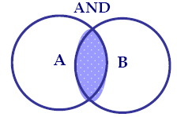
- OR - Connector “OR” is used between the keywords to broaden the search. The search engine will retrieve those documents that contain at least one of these words. Example: A OR B
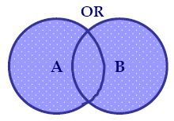

- NOT - Connector “NOT” is used before a keyword to exclude the keyword from the search. Using “NOT” will also narrow down search. Using “NOT” will decrease the number of hits in the result list. The best use of “NOT” is when searching for a keyword that may have multiple meaning. Some search engines allow the use of minus sign “-” which also works the same as “NOT.” Example: A NOT B

ii) Truncation/Wildcard

Truncation allows searches by the root of the word and for anything added onto the trunk of the word. For example:
“child?” to search for child, children, etc.
“child*” to search for child, children, etc.
“child$” to search for child, children, etc.

Wildcard replaces a character in the search term.
For example: wom*n searches for woman or women; organi*ation searches for organization or organisation.

iii) Field Search
Most search engines allow users to search by fields. This function allows the capability of limiting search results to parts of a Web page, for example, URLs, headings, summaries, images and so forth. Using field search will bring fewer but more precise hits because it fetches records that contain the search terms in the subject field only. However, the words used in the subject field are drawn from the controlled vocabulary. Thus, if the search terms used are not recognized as a subject in the system, this will end up with zero hits.

iv) Keyword and Phrase Search
Beginning with keyword search is a good starting point when user is new to the research topic. This is because keyword search fetches records that contain the search terms in all fields. As a consequence, there will be more hits to help user focus and narrow down the research topic. Phrase is a string of words that must appear next to each other. For example “information science” and “global warming”. Most search engines require double quotation marks (“ ”) to differentiate a phrase from word searched separately.

3.2. Indian Search Engines

Indian search engines refer to local Web search engines that are specially targeted or focus on Indian related web sites and homepages. As listed by the website http://www.philb.com/ cse/india.htm (Indian Search Engines, 2009) there are ninety five (95) Indian Web search engines and directories, whereas in 2008, stylusinc.com (Indian Search Engines, 2008) had listed only ten (10) (Appendix - IV). In spite of this large number of Web search engines and directories, only a few of them are available for use. These varieties of search aids consist of search engines with subject directories, search directories and specialized search engines with subject directories.

3.2.1. Google India

‘Google India’ is ‘Google search engine localized for users in India’ (Google, 2010), whose official website address is ‘www.google.co.in’. Google Search or Google Web Search is a web search engine owned by Google Inc. and is the most-used search engine on the Web. The name "Google" originated from a misspelling of "googol," which refers to the number represented by a 1 followed by one-hundred zeros. The name reflects the immense volume of information that exists, and the scope of Google's mission: to organize the world's information and make it universally accessible and useful. The company is running thousands of servers worldwide, which process millions of search requests each day and about 1 petabyte of user-generated data every hour. Having found its way increasingly into everyday language, the verb, "google," was added to the Merriam Webster Collegiate Dictionary and the Oxford English Dictionary in 2006, meaning, "to use the Google search engine to obtain information on the Internet."

3.2.1.1. History

The history of Google (Google history, 2010) is not very old. Google began in January 1996 as a research project by Larry Page, a Ph.D. student at Stanford University. In search for a dissertation theme, Page considered—among other things—exploring the mathematical properties of the World Wide Web, understanding its link structure as a huge graph. His supervisor Terry Winograd encouraged him to pick this idea (which Page later recalled as "the best advice I ever got") and Page focused on the problem of finding out which web pages link to a given page, considering the number and nature of such backlinks to be valuable information about that page (with the role of citations in academic publishing in mind). In his research project, nicknamed "BackRub", he was soon joined by Sergey Brin, a fellow Stanford Ph.D. student and close friend, whom he had first met in the summer of 1995 in a group of potential new students which Brin had volunteered to show around the campus. Page's web crawler began exploring the web in March 1996, setting out from Page's own Stanford home page as its only starting point. To convert the backlink data that it gathered into a measure of importance for a given web page, Brin and Page developed the PageRank algorithm. Analyzing BackRub's output—which, for a given URL, consisted of a list of backlinks ranked by importance—it occurred to them that a search engine based on PageRank would produce better results than existing techniques (existing search engines at the time essentially ranked results according to how many times the search term appeared on a page). A small search engine called RankDex was already exploring a similar strategy.
Convinced that the pages with the most links to them from other highly relevant Web pages must be the most relevant pages associated with the search, Page and Brin tested their thesis as part of their studies, and laid the foundation for their search engine. Originally the search engine used the Stanford website with the domain google.stanford.edu. The domain google.com was registered on September 15, 1997. They formally incorporated their company, Google Inc., on September 4, 1998 at a friend's garage in Menlo Park, California.
By the end of 1998, Google had an index of about 60 million pages. The home page was still marked "BETA", but an article in Salon.com already argued that Google's search results were better than those of competitors like Hotbot or Excite.com, and praised it for being more technologically innovative than the overloaded portal sites (like Yahoo!, Excite.com, Lycos, Netscape's Netcenter, AOL.com, Go.com and MSN.com) which at that time, during the growing dot-com bubble, were seen as "the future of the Web", especially by stock market investors.
The Google site often includes humorous features such as cartoon modifications of the Google logo to recognize special occasions and anniversaries. Known as "Google Doodles", most have been drawn by Google's international webmaster, Dennis Hwang. Not only may decorative drawings be attached to the logo, but the font design may also mimic a fictional or humorous language. It had the Beta version of Google Scholar (http://scholar.google.com) released in November 2004.

3.2.1.2. Google search basics

Searching for information through Google is simple: just type whatever comes to mind in the search box, hit Enter or click on the Google Search button, and Google will search the web for pages that are relevant to the query. Some basic facts (Google search, 2009) about Google search are:
- Every word matters. Generally, all the words you put in the query will be used. There are some exceptions.
- Search is always case insensitive. Searching for [new york times] is the same as searching for [ New York Times ].
- With some exceptions, punctuation is ignored (that is, search can't be for @#$%^&*()=+[]\ and other special characters).

3.2.1.3. How to read search results
Google's goal is to provide the results that are clear and easy to read. The four points given below are important to understand the search results:
- The title: The first line of any search result is the title of the webpage.
- The snippet: A description of or an excerpt from the webpage.
- The URL: The webpage's address.
- Cached link: A link to an earlier version of this page. Click here if the page you wanted isn't available.

Figure 3.4: Search results display details

3.2.1.4. Search Process
The three key processes (Search process, 2010) in delivering search results are:
- Crawling - is the process by which Googlebot discovers new and updated pages to be added to the Google index.
- Indexing - Googlebot processes each of the pages it crawls in order to compile a massive index of all the words it sees and their location on each page.
- Serving results - When a user enters a query, our machines search the index for matching pages and return the results we believe are the most relevant to the user.

3.2.1.5. Search Features

Google has some remarkable search features (Search features, 2009):

PageRank Technology - PageRank is a technology that scores web pages by how "important" they are in relation to other web pages. In the past years, Google has received wide press recognition and praise for the quality relevant results that they serve to web surfers. One of the major reasons for this is success is due to their PageRank Technology. Another major reason is that Google does not over-populate, or flood, their search results pages with two or three third-party databases like various other popular search engines. In order to accomplish this Google combines PageRank with sophisticated text-matching techniques to find pages that are both important and relevant to the search.

Keyword proximity - Google use keyword proximity information to increase relevance a great deal. When Google index web pages, each document is converted into a set of word occurrences called hits. The hits record the word, position in document, an approximation of font size, and capitalization. Google considers each hit to be one of several different types (title, anchor, URL, plain text large font, plain text small font, ...), each of which has its own type-weight. hits occurring close together in a document are weighted higher than hits occurring far apart. The hits from the multiple hit lists are matched up so that nearby hits are matched together. For every matched set of hits, proximity is computed. The proximity is based on how far apart the hits are in the document. Counts are computed not only for every type of hit but for every type and proximity. Count-weights increase linearly with counts at first but quickly taper off so that more than a certain count will not help.

Anchor text - Google use anchor text mostly because anchor text often provide more accurate descriptions of web pages than the pages themselves. Anchor text provides a lot of information for making relevance judgments and quality filtering. The use of link text as a description of what the link points to helps the search engine return relevant (and to some degree high quality) results.

Search syntax - Google's search engine normally accepts queries as a simple text, and breaks up the user's text into a sequence of search terms, which will usually be words that are to occur in the results, but may also be phrases, delimited by quotations marks ("), qualified terms, with a prefix such as "+", "-", or one of several advanced operators, such as "site:".

Special features - Besides the main search-engine feature of searching for text, Google Search has more than 22 "special features" (activated by entering any of dozens of trigger words) when searching : weather, stock quotes, time, sports scores, unit conversion, currency conversion, dictionary lookup, maps, etc.

3.2.1.6. Services and tools
Google provides a lot of services in through its websites. Some important services and products are mentioned below.
- Alerts: - Get email updates on the topics of your choice
- Blog Search: - Find blogs on your favorite topics
- Google Chrome: - A browser built for speed, stability and security
- Directory: - Search the web, organized by topic or category
- Images: - Search for images on the web
- News: - Search thousands of news stories
- Scholar: - Search scholarly papers
- Web Search: - Search billions of web pages
- Gmail - Gmail is a free webmail, POP3 and IMAP service provided by Google. In the United Kingdom and Germany, it is officially called Google Mail.
- Google book search – Searching depository of digital books (Google Book Project).
- Advance search – Facility for searching specific information.
- Go mobile – Get Google services on mobile phone.

The products and services available in the Google website:

Figure 3.5: Image of Google Products site

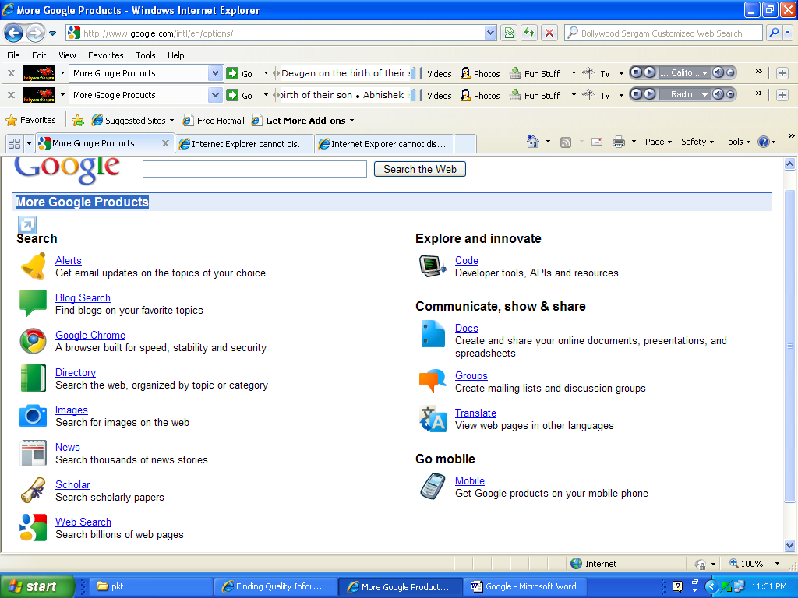
(Source: http://www.google.com/intl/en/options )

3.2.2. Yahoo India

‘Yahoo India’ is the Indian version of international search engine ‘Yahoo’, developed to deal with the documents and websites hosted in India. The official website address of Yahoo is www.yahoo.co.in. Yahoo is a search engine, subject directory, and web portal. Basically the feature of Yahoo is web directory, powered by human being in its indexing and analysis of the retrieval mechanism. Before Google coming to the market it was the unbeaten major public search tool to retrieve information from web. It provides good search results powered by their search engine database, along with many other Yahoo search options, such as ‘Yahoo Reference Search’, or for an even more complete list, check out ‘Ultimate Yahoo Search List’. Thus its retrieval performance tremendously matches with the human information need.

3.2.2.1. History
The early history (Yahoo history, 2010) says, in January 1994, Stanford University graduate students Jerry Yang and David Filo created a website named "Jerry's Guide to the World Wide Web". In April 1994, "Jerry's Guide to the World Wide Web" was renamed "Yahoo!". Jerry's Guide to the World Wide Web was a directory of other web sites, organized in a hierarchy, as opposed to a searchable index of pages. It has since evolved into a major Internet brand with search, content verticals, and other web services. Like many search engines and web directories, Yahoo! diversified into a Web portal. On February 18, 2004, Yahoo! dropped Google-powered results and returned to using its own technology to provide search results. In early 2006, Yahoo! offered users the chance to beta test a new version of the Yahoo! homepage. Today, Yahoo! Inc. is a leading global Internet communications, commerce and media company that offers a comprehensive branded network of services to millions of individuals each month worldwide. As the first online navigational guide to the Web, www.yahoo.com is the leading guide in terms of traffic, advertising, household and business user reach. Yahoo! is the No. 1 Internet brand globally and reaches the largest audience worldwide.

3.2.2.2. Yahoo Home Page
Yahoo offers many search options on its search portal page; including the capacity to search the web, search for images only, search in Yahoo Derctory ( this gathers results from the human edited subject directory, as opposed to main search engine driven results page), search locally, search news, and go shopping (Yahoo Home Page, 2009).

3.2.2.3. Yahoo search options
- Yahoo: main web portal and general jumping off point, where from one can access all big Yahoo search options, suach as Yahoo Mail, Yahoo Music, Yahoo News, etc.
- Yahoo Search: Yahoo’s main page dedicated only to search, also accessable from webportal (image is given below).
- Yahoo Directory: Yahoo’s subject derectory page. Yahoo is one of the oldest directories on the web, and it is also a very large directory.
- Advance search: For minute search with boolean and milti-boolean aearch options. The image is given below.
- Reference search: For searching reference materials from its database.

Figure 3.6 : Website image of search engine Yahoo India
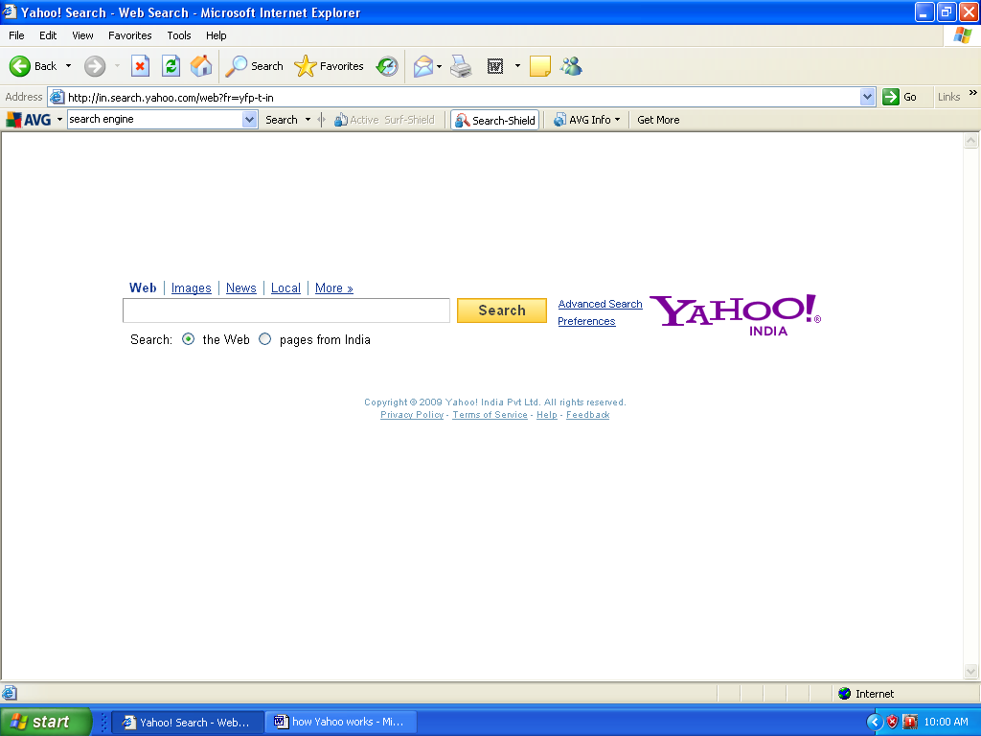
(Source: http://in.search.yahoo.com/web?fr=yfp-t-in )

Figure 3.7: Advance web search of Yahoo India

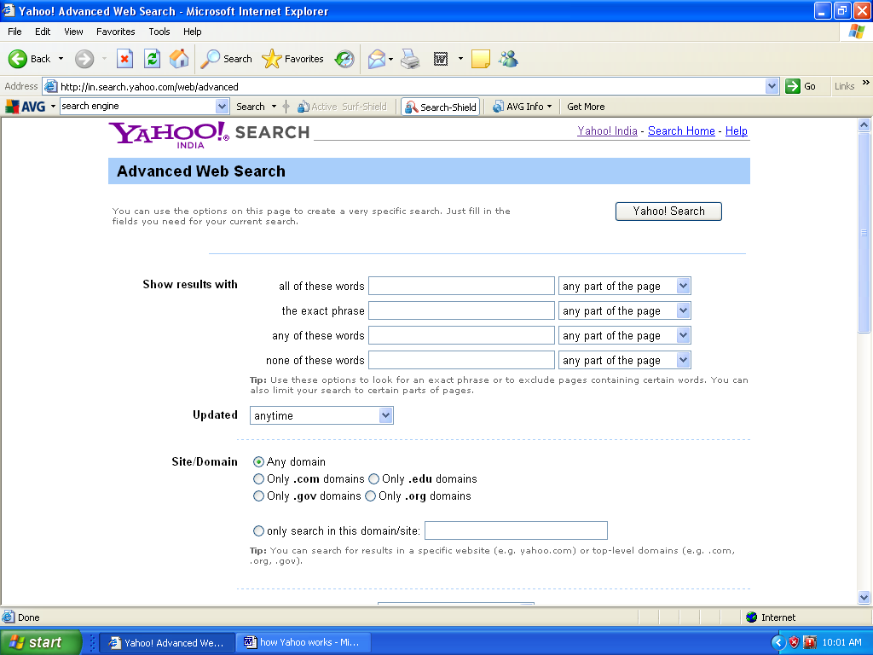
(Source: http://in.search.yahoo.com/web/advanced )

3.2.2.4. Yahoo Searching guide
  - Be concise: Because Yahoo results are both from a human edited and its own search engine, the results may not be as targeted as one might like then to be. Narrowing down the search some specifickeyword will help, which can be helped by ‘Yahoo search Shortcuts’.
  - Use the ‘Search View’: Yahoo’s main search page has tabs with various search view links, such as Images, Video, Directory, etc. that will help in refining the search further.
  - Use Yahoo keywords: If someone wants quick, specific results, one can usually get them by targetting keywords that Yahoo gives as ‘Shortcuts’ to find what one wants.

3.2.3. AltaVista India
AltaVista India is the localised version of international search engine ‘Altavista’, for Indian searchers.

Figure 3.8: Image of Altavista website

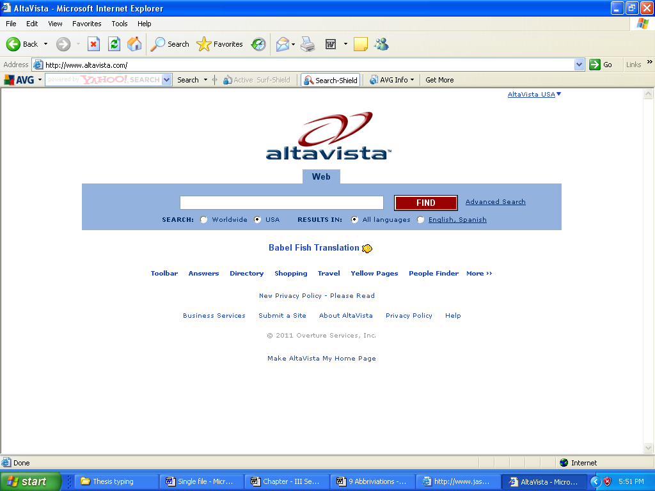
(Source: http://www.altavista.com/)

3.2.3.1. What is AltaVista?

AltaVista is a crawler-based search engine (Altavista, 2009):, meaning that it sends out software programs called spiders, or crawlers, to search the Web and index websites. It is one of the oldest search engines. A cornerstone of AltaVista's mission is to provide access to information to the global community, and company is dedicated to setting the standard for search technology and how people find information.

3.2.3.2. History
AltaVista, which means "a view from above," (altavista.com, 2009) was inspired by the creation of big ideas from a team of experts with a fascination for keeping track of information. During the spring of 1995, scientists at Digital Equipment Corporation's Research lab in Palo Alto, CA, devised a way to store every word of every HTML page on the Internet in a fast, searchable index. This led to AltaVista's development of the first searchable, full-text database on the World Wide Web.
Other notable AltaVista inventions include the first-ever multi-lingual search capability on the Internet and the first search technology to support Chinese, Japanese and Korean languages. Babel Fish, the Web's first Internet machine translation service that can translate words, phrases or entire Web sites to and from English, Spanish, French, German, Portuguese, Italian and Russian.
AltaVista has the honor of being one of the oldest search engines on the Web, since it started way back (this is a long time in Internet years) in 1995 with the Internet's first Web index. Just as a quick age comparison, Google started in 1998, and Yahoo started out as an Internet guide in 1994.

Here are some other "firsts" and notable highlights of AltaVista, straight from the ‘About Us’ page:
- Delivers Internet's first Web index (1995)
- First multilingual search capabilities on the Internet
- First Internet search engine to launch Image, Audio, and Video search capabilities
- Most advanced Internet search features and capabilities: multimedia search, translation & language recognition, and specialty search
- Awarded 61 search-related patents, more than any other Internet search company

3.2.3.3. AltaVista Search Home Page
The AltaVista home page is sleekly elegant. There is a search bar smack in the center, with various tabbed search options, including Images, MP3/Audio, News, and Video. Search filters are available immediately; you can choose to limit your search just to the United States (default), or you can go worldwide. You can also return results in all languages (default), or choose to go with just English or Spanish language results.

Underneath the main blue search bar area, there are textual links going to Translate, Toolbar, Directory (this link goes to Yahoo's Directory, since AltaVista's results are all provided by Yahoo), Shopping (which goes to Yahoo Shopping), Travel - Yahoo Farechase, Yahoo Yellow Pages, Yahoo People Finder, and then (as if that wasn't enough!), there's a link to More, which sends you right into AltaVista's Tools section. Lots of good stuff here, including a text-only Web search tool, AltaVista's Family Filter, and a nifty Conversion Calculator, etc.

3.2.3.4. Searching with AltaVista
A casual search for first any topic returns results that were exactly like what is got in Yahoo on that topic. Again, that's because AltaVista's search results are all powered by Yahoo. The search results page is as sleekly streamlined as the home page, a refreshing contrast to some other search tools that inundate the searcher with ads as soon as they land on the results page. As the Web becomes larger and more complex, finding relevant information efficiently has become increasingly vital to Internet users. By innovating the proven search technology and adapting to the changing complexity of the Internet, the users are helped to find what they need quickly and intuitively. The topical searches aggregate information into highly segmented indexes, helping users refine their searches and quickly access the most pertinent and useful information. The company's `Power of Precision' philosophy underlies everything done to deliver the most powerful search tools available. We continue to evolve with new initiatives dedicated to continually improving freshness, quality and relevancy to help users get the precise results they seek.

3.2.3.5. AltaVista Search Features
Special features of Altavista are awesome:

- AltaVista BabelFish - the Babel Fish Translation Tool that can translate words, phrases or entire Web sites
- AltaVista MP3, Audio, and Video Search. AltaVista's MP3 and Audio Search also returns excellent results, and their Video Search ain't too shabby in the results department either.
- AltaVista Advanced Search AltaVista also has Advanced Search options that allow you to set some pretty stringent parameters on your search, including Boolean expressions and file types.
- AltaVista toolbar gives you standard toolbar options along with the Babel Fish translation tool right there on your desktop, easily accessible once you install the toolbar.

3.2.4. Rediff
The ‘Rediff.com India’ website consists of information, communication and content services, free and paid community features and products, including e-commerce and mobile services. Rediff.com provides a platform for Indians worldwide to connect with one another online. Rediff.com is committed to offering a personalized and a secure surfing and shopping environment. Founded in 1996, Rediff.com is headquartered in Mumbai, India with offices in New Delhi, Bangalore, Chennai, Hyderabad and New York, USA.

Mission In The Internet Space
To provide world-class online consumer service offerings to Indians worldwide.

Figure 3.9 : Website image of search engine Rediff.com
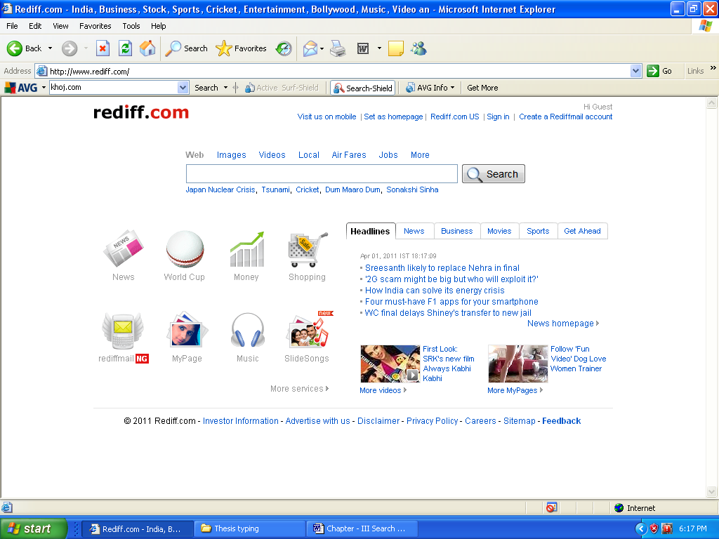
(Source: www.rediff.com)

3.2.4.1. Information and Content
Information and content channels currently include news, business, movies, cricket/sports and several other topics of interest.

News content includes:
- Current affairs and breaking news: Rediff provides breaking news focused on events of interest to Indians, including feature news stories, interviews and online chats with leading Indian personalities.
- Business: This channel covers the happenings of corporate India, stock market quotes and analysis, regular columns and feature stories, as well as personal portfolio tracker.
- Movies and Entertainment: For latest news and trends from Bollywood and Hollywood. Box office information, regular columns, feature stories, interviews with movie personalities, movie reviews and slide shows.
- Sports and Cricket: Provides coverage of Indian and global sporting news. There is in-depth coverage of cricket news from India and around the globe, with statistics, scores and schedules, regular columns, feature stories and interviews.
- Get Ahead: Aimed at enriching the lifestyle of younger online audiences, this section cover topics of interest such as careers, education, relationships, work environments, among others.
- Message Board : Rediff.com offers a Message Board facility through which users can post their comments.

3.2.4.2. Community Features and Products
A key focus for Rediff.com is using world-class technology to drive community building. Through a single login facility, Rediff.com provides a combination of free and paid community features and products to consumers and businesses. These include e-mail, instant messaging, Search, Chat, Blogs, Message Boards, Social Networking, Mobile services, online shopping and auctions.
- Rediffmail: Rediffmail is the flagship product of Rediff.com. It is one of the most popular web e-mail service used by Indians world wide. Rediffmail offers users a complete outlook desktop experience with features like unlimited storage, instant mail preview, quick attachments of up to 10 MB, Drag & Drop facility to manage your folders and auto address completion. It supports eleven Indian languages and also comes with the integrated web-messenger allowing all Rediffmail users to chat in real-time with all their Rediff Bol (Instant Messenger) users within their inbox.
- Rediff Web Search provides a comprehensive directory of information adapted to provide relevant search results.
- Fare Search is the Rediff’s first vertical search product that allows users to search and compare airfares across domestic carriers for all destinations served. The Fare search is also extended to include Train Search, which allows users to find trains, check ticket availability, PNR status. The product also gives you comparison view of trains available between two stations and the lowest airfare ticket available between the same routes.
- Job Search is vertical search product, which allows users to search for jobs across various job sites in India under several categories and locations in India.
- Image Search is one of the popular search services offered by Rediff.com. Users can search from over 1 billion images share the images with their friends from the system itself.
- Rediff Product Search allows users to compare products across brands, features, price points, user ratings and check availability of the products in their city at local stores with complete contact details. The service covers more than 16 product categories under electronics and also covers Cars and Bikes as new categories.
- Rediff iShare: Rediff iShare is a rich multimedia social content sharing platform which allows users to share videos, music, pictures all on a single platform
- Rediff Moneywiz provides stock market quotes, analyses and market voices, a live running commentary updated every few minutes. It also provides facility of personal portfolio tracker to users.
- Rediff Pay4Clicks Classifieds is the Company’s performance based advertising platform. Users can send their responses directly to the advertiser over email or to the mobile phone using SMS. We have also integrated our reseller channel to this platform and provided them with a tool that allows them to upload multiple ads in a single user session.
- Rediff Q & A is social media community platform, which allows users to ask and answer questions posed by the Rediff community. The platform encourages participation through recognizing the top performers of the week by featuring them in the ‘Hall of Fame’ section.
- Rediff iLand: Rediff iLand is a social networking and a blogging platform that empowers users to share and express their views and form a community of like-minded users. The platform supports eight Indian languages like Hindi, Marathi, Tamil, Telgu, Malayalam, Kannada, Bengali and Gujarati, allowing users to blog in the language they are most comfortable in.
- Rediff Bol instant messenger is a free service that works even on low bandwidths. Users can make PC-to-PC voice phone calls; send SMS to mobile phones in India and create customized avatars and participate in chat rooms.

3.2.5. Guruji
Guruji is the crawler based algorithmic search engine for India. It is is focused on providing better search results to Indian consumers, by leveraging proprietary algorithms and data in the Indian context. It searches Web, Music, Images and many more from Internet.
3.2.5.1. General Information :

- Founded in 2006
- Website address guruji.com ,
- Blog address blog.guruji.com,
- Email address contact@guruji.com,
India, known for being the spiritual Guru of the world, is now seeking to become the technology Guru with Indians spearheading the IT revolution. With Guruji.com, a totally indigenous product, it is aspired to become a world-class search engine and showcase the "Indian" content to the world.
Guruji.com is the first crawler based search engine developed completely in India and designed to make search simple for Indian users. Guruji, a respectful way to call one's teacher, is the person one seeks help from in times of need. Likewise, Guruji.com is built to help provide easy access to information in every walk of life. Their proprietary algorithms automatically identify content on the web and organize it in such a way that Indian users get search results that are relevant to them. It was started by two IIT-Delhi graduates Anurag Dod and Gaurav Mishra, Guruji.com now offers search verticals like Music, Finance, Image, City, Movie Timings besides web search. They also run a ad network under the adGuru banner.
Figure 3.10 : Website image of search engine Guruji.com
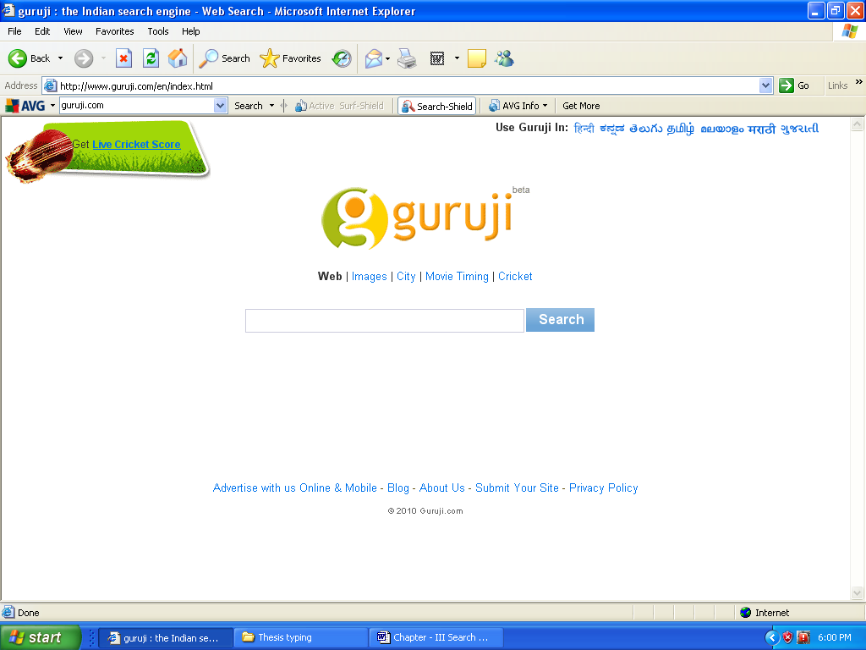
(Source: www.guruji.com)
3.2.6. Khoj
‘Khoj’ is a local search engine provides comprehensive updated information on web directory and offers to find people by name and get their details. Its counter part ‘Khoj Been’ is a world wide web search engine & free web directory. This directory will help in finding the quality website over the Internet in the world. Khoj searches in English, Hindi, Tamil, Telugu, and in some other Indian languages. Its website address is http://www.khoj.in.

Khoj.com ("Khoj. Directory of links, news, features, search engine powered by AltaVista") is a domain controlled by two name servers at ‘satyam.net.in’. Both are on the same IP network. The name server ‘khoj.com’ stated in SOA record is not in the list of name servers. Incoming mail for ‘khoj.com’ is handled by one mail server at ‘indialine.com’. ‘khoj.com’ has one IP number (210.210.109.33) , but the reverse is ‘210-210-109-33.lan.sify.net’. ‘Khoj.in’, ‘www.khoj.in’ and ‘210-210-109-33.lan.sify.net’ point to the same IP. ‘Dspml.com’, ‘bnpindia.com’, ‘rahejak.com’, ‘syndicatebank.com’, ‘krahejamumbai.com’ and at least two other hosts share both name servers and mail servers with this domain. ‘Exactuscorp.com’, ‘ambattur.com’, ‘impulse-india.com’, ‘dpsmedia.net’, ‘dailythanthi.com’ and at least 200 other hosts share name servers with this domain. ‘Etravelplaza.com’, ‘grouptci.com’, ‘mhril-web.com’, ‘synd-bank.com’, ‘watertreatmentchemicalexpoters.com’ and at least 200 other hosts share name servers under another name with this domain. ‘Icicimarkets.com’, ‘jkfilesandtools.com’, ‘jeena.com’, ‘bluestarindia.net’, ‘colgate.co.in’ and at least four other hosts share mail servers with this domain. ‘Fraser-todd.com’ share mail servers under another name with this domain. ‘Www.khoj.com’, ‘postmaster.khoj.com’ and ‘m.khoj.com’ are sub-domains to this hostname.
People are also interested in ‘khoj2.com’, ‘khoj4.com’, ‘khoja.com’, ‘khoj4u.com’ and ‘khel.com’. ‘Khoj.com’ is ranked #185722 world wide and is hosted on a server in India. It has gained 423 inlinks over a period of 14 years. It has 1 organic keywords. Trustworthiness, vendor reliability, privacy and child safety of this site is excellent.It is not listed in any blacklists. It is listed in Regional/Asia/India/Guides_and_Directories/Search_Engines.
Figure 3.11 : Website image of search engine Khoj.com 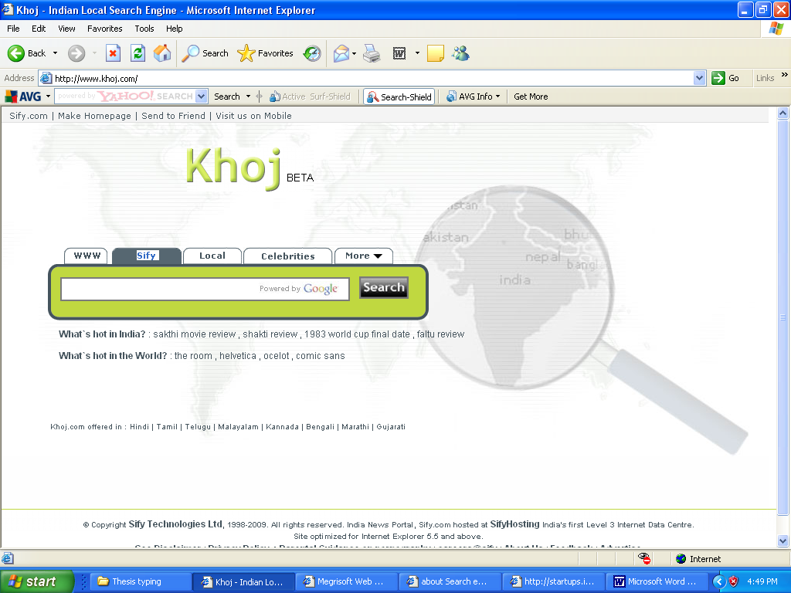
(Source : www.khoj.com)

3.3. Reference
Agosti, M. (2000). Information Retrieval on the Web. ESSIR: Varenna, Italy
Altavista. (2009). Retrieved December 06, 2009 http://websearch.about.com/od/engine-sanddirec-tories/a/altavista.htm
Altavista.com. (2009). Retrieved May 25, 2009 http://in.altavista.com/about
Asadi, S., & Jamali, H.R. (2004). Shifts in search engine development: A review of past, present and future trends in research on search engines. Webology, 1(2). Retrieved November 24, 2007 from http://www.webology.ir/2004/v1n2/a6.html
Baeze-Yates, R. & Riberio-Neto, B. (1999). Modern Information Retrieval. New York: Addision Wesley.
Barker, J. (2005). How do Search Engines Work? The Best Search Engines. Retrieved February 02, 2005 from http://www.lib.berkeley.edu/TeachingLib/Guides/Internet/ SearchEngines.html
Brin, S. & Page, L. (1998). The anatomy of a large-scale hypertextual web search engine. Proceedings of the 7th International WWW Conference, Brisbane, Australia, 107-117.
Cho, W. C. & Richards, D. (2007). Ontology construction and concept reuse with formal concept analysis for improved web document retrieval. Web Intelligence and Agent Systems: An international journal, 5, 109–126.
Chu, H. & Rosenthal, M. (1996). Search Engine for www: a comparative study and evaluation methodology. In ASIS Annual conference proceedings, Baltimore, MD, October 19-24, 1996, (pp.127-135). Retrieved July 30, 2009 from http:/www.asis.org/annual-96/Electronproceeding/chu.html
Chu, H. & Rosenthal, M. (1996). Search Engine for www: a comparative study and evaluation methodology. In ASIS Annual conference proceedings, Baltimore, MD, October 19-24, 1996, (pp.127-135). Retrieved July 30, 2009 from http:/www.asis.org/annual-96/Electronproceeding-/chu.html
Cleverdon, C.W. (1972). On the inverse relationship of recall and precision, Journal of Documentation, 28, 195-201.
Cleverdon, C.W., Mills, J. & Keen, M. (1966). Factors Determining the Performance of Indexing Systems, Vol. I, Design, Vol. II, Test Results, ASLIB Cranfield Project.
Fryer, D. (2004). Federated search engines. Online, 28(2), 16-19.
Google history. (2010). Retrieved February 12, 2010 from http://en.wikipedia.org/wiki/# Early_history
Google search. (2009). Retrieved May 05, 2009 from http://www.google.com/support/ websearch/ bin/
Google. (2010). Retrieved February 02, 2010 from http://search.lycos.ca/?tab=image &query=google+india+ search+engine&Search
Greg, R, (2004).Search Engine New, Retrieved December 01, 2004 from http://searchengine-showdown.com/ stats/dead.shtml
Indian Search Engines. (2008). Retrieved August 28, 2008 from http://www.stylusinc.com /indian_search_ engines/index.htm
Indian Search Engines. (2009). Retrieved May 26, 2009 from http://www.philb.com/cse/india.htm
Information Retrieval. (2009). In Wikipedia. Retrieved September 22, 2009 from http://en.wikipedia. org/ wiki/Informaiton _retrieval
Kobayashi, M & Takeda, K. (2000). Information Retrieval on the Web. Retrieved January 21, 2008 from http://www.libnet.sh.cn/sztsg/ko/reference/kobayashi00information.pdf
Lancaster, F.W. (1968). Information Retrieval Systems: Characteristics, Testing and Evaluation. New York: Wiley.
Lawrence, S. (2000). Context in Web Search. Proceedings of the IEEE Data Engineering Bulletin, 23(3), 25–32.
Leighton, H.V. & Srivastava, J. (1999). First 20 precision among world wide web search services (search engine). Journal of the American Society for Information Science, 50(10), 870-81.
Lesk, M.E. & Salton, G. (1969). Relevance assessments and retrieval system evaluation, Information Storage and Retrieval, 4, 343-359.
Luhn, H.P. (1957). A statistical approach to mechanised encoding and searching of library information. IBM Journal of Research and Development, 1, 309-317.
Ma, W., Zhang, H. & Hon, H. (2004). Towards Next Generation Web Information Retrieval. Web Information Systems – WISE04: Proceedings of the fifth international Conference on Web Information System Engineering, Brisbane, Australia, 17.
Mahesh, K. (2004). Text Retrieval Quality: A Primer. Retrieved November 4, 2004 from http://www.oracle.com/technology/products/text/htdocs/imt_quality.htm
Maron, M.E. (1988). Probabilistic design principles for conventional and full-text retrieval systems. Proceedings of the Information Processing and Management, 24(3) 249–255.
Poulter, A. (1997). The design of World Wide Web search engines: a critical review, Program, 31(2), 131-145.
Rijsbergen, C.J. (1979). Information Retrieval (2nd ed.). London: Butterworths. Retrieved October 20, 2004 from http://www.dcs.gla.ac.uk/Keith/Preface.html
Salton, G. (1968). Automatic Information Organization and Retrieval. New York: McGraw-Hill
Salton, G., Fox, E.A. & Wu , H. (1983). Extended Boolean Information Retrieval. Proceedings of the Communication of the ACM, 26(11). 1022–1036.
Search engine types, (2008). Retrieved January 08.2008 from http://www.standford.edu class/ archive/cs/cs276a/ cs276a.1032/handouts/tutbib_4.html
Search Features. (2009). Retrieved December 24, 2009 from http://www.pwqsoft.com/ search- engine- ranking.htm
Search Process. (2010). Retrieved September 23, 2010 from http://www.google.com/support/ webmasters/bin/ answer.py?answer=70897
Search tools. (2010). Retrieved March 19, 2010 from http://www.searchtools.com/info/ir-nlp.html
Shannon, C.E. & Weaver, W. (1964). The Mathematical Theory of Communication. Urbana: University of Illinois Press.
Singer, M. (2004). Yahoo sends search aloft. Retrieved November 28, 2004, from http://www. internetnews.com/bus-news/article.php/3427831
Wall, A. (2004). History of search engines & web history. Retrieved December 3, 2004, from http://www.search-marketing.info/search-engine-history/
Wang, Z. (2001). Information Systems and Evaluations: Precision and Recall Graphs. Retrieved January 16, 2005 from http://www2.sis.pitt.edu/~ir/Projects /Sum01/FinalProjectsSum/ ZhangWang/ZhangWang-finalproje cthandin/List.htm
Wardrip-Fruin, N. & Montfort, N. (Eds). (2003). The New Media Reader. Massachusetts: MIT Press. Retrieved March 17, 2010 from http://www.newmediareader.com/book_contents.html
Webster, P. (2004). Metasearching in an academic environment. Online, 28(2), 20-23.
Woetzel, D. (2004). Online Searching Techniques. Internet Research Techniques. Retrieved January 12, 2005 from http://webster.gtcc.cc.nc.us/library/searchtechniques.html#boolean
World Wide Web Consortium. (2010). Retrieved March 10, 2010 from http://www.w3.org/History /19921103-hypertext/ hypertext/ WWW/TheProject.html
Wright, A. (2007). In search of the deep Web. Retrieved December 5, 2007, from http://www. salon.com/tech/future/2004/03/09/deep_web/index_np.html.
Yahoo history, (2010). Retrieved August 28, 2010 from http://en.wikipedia.org/wiki/History_ of_Yahoo
Yahoo Home Page. (2009). Retrieved December 06, 2009 from http://websearch.about.com/od/ yahoo/a/yahoo.htm

